T.Y. B.Sc. C.S. Sem-V Roll No : 713 Date: / /2020

Practical no 1

AIM: WAP in Java to implement the following Substitution Cipher Techniques.

1. Caesar cipher Program code:

package javaapplicationins; import java.io.*;

import java.util.Scanner; public class CaesarCipher

{

public static void main(String[] args)

{

CaesarCipher c=new CaesarCipher(); Scanner s= new Scanner(System.in); System.out.println("Performed by krunal 713"); System.out.println("Input Data to encrypt"); String str=s.nextLine(); System.out.println("Input the key");

int key=s.nextInt();

String encrypted=c.encrypt(str,key); System.out.println("Encrypted Data:"+encrypted); String decrypted=c.decrypt(encrypted,key); System.out.println("Decrypted Data:"+decrypted);

}

String encrypt(String str,int key)

{

String encrypted="";

for(int i=0;i<str.length();i++)

{

int c=str.charAt(i); if(Character.isUpperCase(c))

{

c=c+key; if(c>'Z'){

c=c-26;

}

}

if(Character.isLowerCase(c))

{

c=c+key; if(c>'z'){ c=c-26;

}

}

encrypted +=(char) c;

}

return encrypted;

}

String decrypt(String str,int key)

{

String decrypted="";

for(int i=0;i<str.length();i++)

{

int c=str.charAt(i); if(Character.isUpperCase(c))

{

c=c-key; if(c <'A'){

c=c+26;

}

}

if(Character.isLowerCase(c))

{

c=c- key; if(c <'a'){

c = c + 26;

}

}

decrypted += (char) c;

}

return decrypted;

}

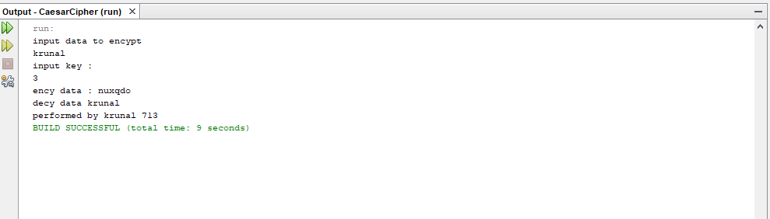}

1. **Monoalphabetic Cipher Program code:**

package javaapplicationins; import java.io.*;

import java.util.Scanner;

public class MonoalphabeticCipher {

public static char p[]={'a','b','c','d','e','f','g','h','i','j','k','l','m','n','o',

'p','q','r','s','t','u','v','w','x','y','z'};

public static char ch[]={'Q','W','E','R','T','Y','U','I','O','P','A','S','D','F','G',

'H','J','K','L','Z','X','C','V','B','N','M'};

public static String doEncryption(String s)

{

char c[]=new char[(s.length())]; for (int i=0;i<s.length();i++)

{

for(int j=0;j<26;j++)

{

if(p[j]==s.charAt(i))

{

c[i]=ch[j]; break; }

}

}

return(new String(c));

}

public static String doDecryption(String s)

{

char pt[]=new char[(s.length())]; for (int i=0;i<s.length();i++)

{

for(int j=0;j<26;j++)

{

if(ch[j]==s.charAt(i))

{

pt[i]=p[j]; break; }

}

}

return(new String(pt));

}

public static void main(String args[])

{

Scanner sc=new Scanner(System.in); System.out.println("Performed by krunal 713"); System.out.println("Enter the message:");

String en=doEncryption(sc.next().toLowerCase()); System.out.println("Encrypted message:"+en); System.out.println("Decrypted message:"+doDecryption(en));

sc.close();

}

}

